SIMATS ENGINEERING
ASSESSMENT TOOL 1

Experiments

COURSE NAME: Computer Networks COURSE CODE: CSA07

COURSE OUTCOME COVERED

CO3: Analyze the performance of core network protocols such as TCP, UDP, HTTP, and DNS under varying conditions

Assessment Tool Weightage: 40%

Code of Conduct:

I Dinesh Bharadwaj(192572028) certify that this submission is my original work and that I have adhered to the guidelines specified for this assessment. I understand that any violation of academic integrity rules will result in disciplinary action.
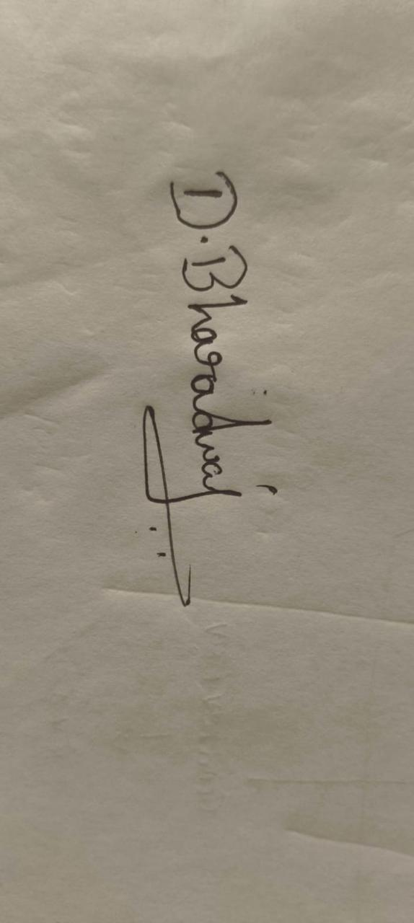
Signature of the student

Experiments

QUESTIONS:4 Total Marks:40

- Capture packets during a TCP connection setup. Identify the three packets involved in the handshake (SYN, SYN-ACK, ACK). Demonstrate the role of each flag and how they establish a reliable connection. (BL4) (10)
- Capture a DNS query using UDP in Wireshark. Compare the UDP header size with TCP and note the absence of sequence numbers or acknowledgments. Discuss how this lightweight design impacts speed and reliability. (BL4) (10)
- Simulate packet loss (e.g., disconnect briefly) and capture traffic in Wireshark. Observe how TCP retransmits lost packets while UDP does not. Explain why this difference makes TCP reliable but slower compared to UDP. (BL4) (10)
- Use Wireshark to capture DNS traffic while resolving a domain name. Identify the query type (A, AAAA, MX) and the response received. Measure the time taken for resolution and explain why DNS typically uses UDP.(BL4) (10)

RUBRICS FOR CALCULATION:

Criteria | Weightag e | Level 4 – Exemplary | Level 3 – Proficient | Level 2 – Developing | Level 1 – Beginning
Understandin g of Concepts | 25 | Demonstrates thorough understanding and effectively integrates multiple concepts/technologi es | Good understandin g with proper integration of most concepts | Basic understandin g; limited or partial integration | Poor understandin g; unable to integrate concepts
Experimental Design | 30 | Well-planned, systematic implementation with optimal solution | Correct implementati on with minor issues | Basic implementati on with errors or inefficiencies | Incorrect or incomplete implementati on
Use of Tools | 20 | Effective and advanced use of tools/technologies with proper configuration | Appropriate use of tools with correct execution | Limited or inconsistent use of tools | Incorrect or minimal use of tools
Analysis of Results | 15 | Insightful analysis with accurate interpretation and validation of results | Good analysis with reasonable interpretation | Basic analysis with limited insights | Poor or incorrect analysis of results
Documentati on | 10 | Clear, well-structured documentation with diagrams, code, and results | Organized documentatio n with necessary details | Basic documentatio n with missing details | Poor or incomplete documentatio n

Experiment 1: TCP Three-Way Handshake

Aim

To capture packets during TCP connection establishment using Wireshark and identify the SYN, SYN-ACK, and ACK packets involved in the three-way handshake.

Requirements

Computer/Laptop

Wireshark

Internet connection

Web browser

Procedure

Open Wireshark.

Select the active network interface such as Wi-Fi or Ethernet.

Start packet capture.

Open a web browser and visit any website.

Stop the capture after the website loads.

Apply the filter:

tcp.flags.syn == 1

Identify the TCP packets involved in connection establishment.

Observe the following three packets:

SYN

SYN-ACK

ACK

Observation
Packet | Flags | Purpose
1 | SYN | Client requests a TCP connection
2 | SYN + ACK | Server accepts the request and acknowledges it
3 | ACK | Client acknowledges the server's response

Working of Three-Way Handshake

Step 1 – SYN

The client sends a SYN packet to the server.

Client Server

| -------- SYN ------------> |

The SYN flag indicates that the client wants to establish a TCP connection. It also contains an initial sequence number.

Step 2 – SYN-ACK

The server responds with SYN + ACK.

Client Server

| -------- SYN ------------> |

| <------ SYN + ACK -------- |

SYN indicates that the server also wants to establish the connection.

ACK acknowledges the client's SYN.

The server sends its own initial sequence number.

Step 3 – ACK

The client sends an ACK.

Client Server

| -------- SYN ------------> |

| <------ SYN + ACK -------- |

| -------- ACK ------------> |

The ACK confirms that the client received the server's SYN-ACK.

After this, the TCP connection is established and data transmission can begin.

Role of Flags

SYN: Synchronizes sequence numbers and starts a TCP connection.

ACK: Confirms successful receipt of data/control information.

SYN + ACK: Server accepts the connection request and acknowledges the client's SYN.

Result

The TCP three-way handshake was successfully captured in Wireshark. The SYN, SYN-ACK, and ACK packets establish a reliable connection by synchronizing sequence numbers and confirming communication between the client and server.

Experiment 2: DNS Query Using UDP

Aim

To capture a DNS query using UDP in Wireshark and compare the UDP header with the TCP header, particularly the absence of sequence numbers and acknowledgments.

Requirements

Computer/Laptop

Wireshark

Internet connection

Command Prompt/Terminal

Procedure

Open Wireshark.

Select the active network interface.

Start packet capture.

Open Command Prompt.

Enter:

nslookup google.com

Stop Wireshark capture.

Apply the filter:

dns

or

udp.port == 53

Select a DNS query packet.

Expand the User Datagram Protocol section.

Observe the UDP header fields.

UDP Header

The UDP header contains only 8 bytes.

It consists of:

Source Port

Destination Port

Length

Checksum

TCP Header

The TCP header is normally 20 bytes or more because it contains additional fields such as:

Source Port

Destination Port

Sequence Number

Acknowledgment Number

Flags

Window Size

Checksum

Urgent Pointer

Options

Comparison
Feature | UDP | TCP
Header size | 8 bytes | Minimum 20 bytes
Sequence number | No | Yes
Acknowledgment number | No | Yes
Connection establishment | No | Yes
Retransmission | No | Yes
Reliability | Low | High
Speed | Faster | Relatively slower
DNS usage | Commonly used | Used when required

Why UDP is Faster

UDP does not establish a connection before sending data. It also does not wait for acknowledgments or retransmit lost packets.

For DNS, the client can simply send:

DNS Query → DNS Server

and receive:

DNS Response ← DNS Server

This reduces overhead and delay.

Effect on Reliability

Since UDP does not provide:

Acknowledgments

Sequence numbers

Automatic retransmission

a lost DNS packet is not recovered by UDP itself. The DNS application can handle the situation by sending another query.

Result

The DNS query was successfully captured using UDP. UDP has a small 8-byte header and does not contain TCP-style sequence and acknowledgment numbers. This lightweight design provides faster communication with less overhead but offers less transport-level reliability.

Experiment 3: TCP Retransmission vs UDP

Aim

To simulate packet loss and observe how TCP retransmits lost packets while UDP does not provide transport-level retransmission.

Requirements

Computer/Laptop

Wireshark

Internet connection

Command Prompt/Terminal

Procedure

Open Wireshark.

Select the active network interface.

Start packet capture.

Generate TCP traffic by opening a website or downloading a file.

To observe TCP retransmission, temporarily interrupt or disturb the network connection during active TCP communication.

Restore the connection.

Stop the capture.

Apply the filter:

tcp.analysis.retransmission

Observe packets marked as TCP Retransmission.

TCP Packet Loss

Suppose a TCP packet is lost:

Sender Receiver

| ---- Packet 1 -------> |

| ---- Packet 2 -------> | X Lost

| ---- Packet 3 -------> |

The receiver detects missing data using sequence numbers and acknowledgments.

TCP eventually retransmits the missing packet:

Sender Receiver

| ---- Packet 2 -------> |

Therefore, TCP ensures that lost data can be recovered.

TCP Reliability Mechanisms

TCP uses:

Sequence numbers

Acknowledgments

Retransmission

Timeout mechanisms

Flow control

Congestion control

These mechanisms make TCP reliable.

UDP Packet Loss

UDP does not have TCP-style retransmission.

Sender Receiver

| ---- UDP Packet ------> | X Lost

If the packet is lost, UDP itself does not resend it.

This is useful for applications where speed is more important than perfect delivery, such as:

Live streaming

Online gaming

Voice communication

Video conferencing

Comparison
Feature | TCP | UDP
Connection | Connection-oriented | Connectionless
Sequence numbers | Yes | No
ACK | Yes | No
Retransmission | Yes | No
Reliability | High | Lower
Speed | Relatively slower | Faster
Overhead | Higher | Lower

Why TCP is Slower

TCP requires additional processing for:

Acknowledgments

Sequence number checking

Retransmission

Flow control

Congestion control

Therefore, TCP generally has more overhead than UDP.

Result

TCP retransmission was observed using Wireshark. TCP retransmits lost packets using sequence numbers and acknowledgments, making it reliable. UDP does not automatically retransmit lost packets, which reduces overhead and makes it faster but less reliable.

Experiment 4: DNS Traffic and Resolution Time

Aim

To capture DNS traffic using Wireshark, identify DNS query types such as A, AAAA, and MX, observe the response, and measure the time required for domain-name resolution.

Requirements

Computer/Laptop

Wireshark

Internet connection

Command Prompt/Terminal

Procedure

Open Wireshark.

Select the active network interface.

Start packet capture.

Open Command Prompt.

Clear the local DNS cache if required.

For Windows:

ipconfig /flushdns

Perform a DNS lookup:

nslookup google.com

Stop the Wireshark capture.

Apply the filter:

dns

Select the DNS query packet.

Expand the Domain Name System section.

Observe the query type and response.

DNS Query Types

1. A Record

The A record maps a domain name to an IPv4 address.

Example:

google.com → IPv4 address

2. AAAA Record

The AAAA record maps a domain name to an IPv6 address.

Example:

google.com → IPv6 address

3. MX Record

The MX record identifies the mail servers responsible for receiving email for a domain.

Example:

example.com → Mail server

Wireshark Observation

In the DNS query packet, observe:

Queries

Name: google.com

Type: A

The response may contain:

Answers

Name: google.com

Type: A

Address: <IPv4 address>

The actual IP address will depend on the DNS server and time of capture.

Measuring Resolution Time

Wireshark displays a Time value for each packet.

Identify:

DNS Query

↓

DNS Response

The approximate DNS resolution time can be calculated as:

Resolution Time = Response Time - Query Time

For example, if:

Query Time = 5.000000 s

Response Time = 5.025000 s

then:

Resolution Time = 5.025000 - 5.000000

= 0.025 seconds

= 25 ms

Your actual value will be different depending on network conditions and DNS server response time.

Why DNS Uses UDP

DNS commonly uses UDP port 53 because DNS queries are generally:

Small

Fast

Simple

Connectionless

Using UDP avoids the TCP three-way handshake.

The communication is approximately:

Client DNS Server

| ---- DNS Query -------> |

| <---- DNS Response ---- |

This provides low latency.

DNS can also use TCP, particularly when responses are large or for certain DNS operations. Modern DNS mechanisms can also use encrypted transports such as DNS over HTTPS or DNS over TLS.

Result

DNS traffic was successfully captured in Wireshark. The DNS query type, such as A, AAAA, or MX, and its corresponding response were identified. The DNS resolution time was calculated by comparing the query and response timestamps. DNS commonly uses UDP because it provides low overhead and fast communication.

